Name: _____________________________________

**Life in the Colonies Scavenger Hunt**

**Part 1:** This is a scavenger hunt! As you search each of the documents in the hunt, complete the chart below about each of the 3 colonial regions and the 13 colonies. After each note that you make, please show which document your information came from like this: (A). By the end of the activity, you will be able to describe the characteristics of the regions and explain how they were different.

|  |  |  |  |  |  |
| --- | --- | --- | --- | --- | --- |
| Region | Colonies | Government | Economics | Society | Additional Facts |
| New England |  |  |  |  |  |
| Mid-Atlantic |  |  |  |  |  |
| Southern |  |  |  |  |  |

**Part 2:** Now that you have looked over the ways in which the colonial regions were similar and different, you will need to complete a pre-writing assignment.

What is your research question?

*Consider finding the correlation between two historical details (ie. How did the economic developments of colonial region A and colonial region B lead to differences in social structures and race relationships?)*

Turn your research question into a statement, which will become your thesis.

*(ie. Social structures and race relationships were directly impacted by the dissimilar economies of colonial region A and colonial region B.)*

Identify at least three categories of research that pertain to your thesis statement/ research question.

*(ie. Economies use land differently, which leads to different population densities. The roles of business owner and worker versus plantation owner and slave lead to changes in social structure. The rise of British intervention in colonial economies of the northern regions led to an equalizing of social structure, unlike in the South.)*

What additional research will you need to conduct to complete your outline for an essay?

Prepare an outline for an essay on your thesis above.

Doc A: Three Types of Colonial Government

**1. Royal Colony**Royal colonies were owned by the king.

* These governments were assigned by the Crown, and carried out the orders and wishes of the Crown instead of private or local interests.
* By 1775 the Royal Colony system of government was in the ***Carolinas, Virginia, Massachusetts, New Jersey, New Hampshire and New York.***

**2. Proprietary Colony**In a Proprietary Colony, an individual, or small elite group, essentially owned the colony, controlling all of the actions and institutions of government, for which they would receive political or financial favors. The governors of the proprietary colonies reported directly to the king.

* By 1775 the Proprietary system of government was in ***Delaware, Maryland, and Pennsylvania.***

**3. Charter Colony**The Charter Colonies were generally self-governed, and their charters were granted to the colonists via a joint-stock company

* When created, the British King granted these colonies a charter establishing the rules of government, but he allowed the colonists a great amount of freedom within those rules
* The Charter system of government was in ***Rhode Island and Connecticut***. The ***Massachusetts Bay Colony*** was a royal province under a charter

Doc. B: The Triangle of Trade

The Triangular Trade is a term used to describe the trade occurring between England, Africa, and the Americas. The trade fell into the three categories:

* The raw materials and natural resources such as ***sugar, tobacco, rice and cotton*** that were found in the 13 colonies.
* Manufactured products from England and Europe such as guns, cloth, beads
* ***Slaves*** from West Africa, many of whom toiled in the [***Slave Plantations***](https://www.landofthebrave.info/plantations.htm)
* ***WHAT PRODUCTS WERE PRODUCED IN THE THREE COLONIAL REGIONS?***

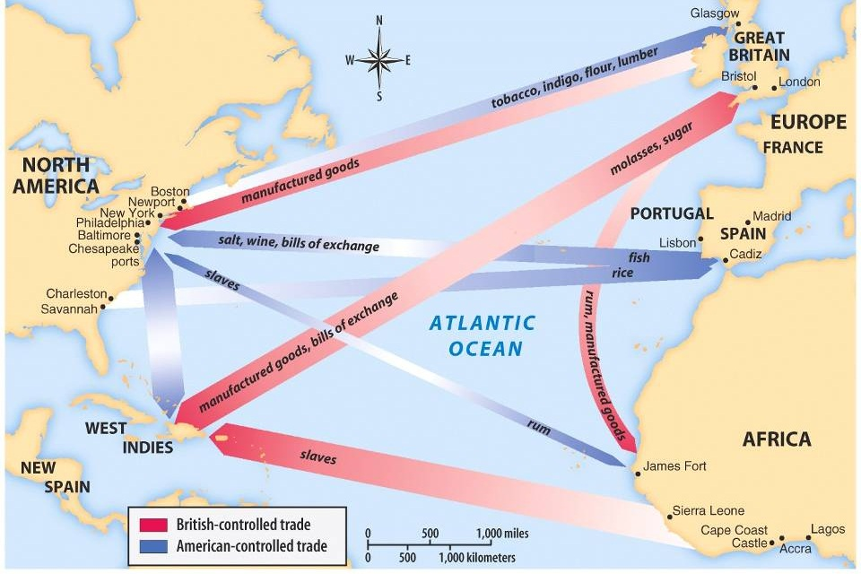

Doc. C: The Value of Colonial Trade

* What regions did these products come from?
* Which products were most valuable to the colonies? Which were most valuable to Great Britain?

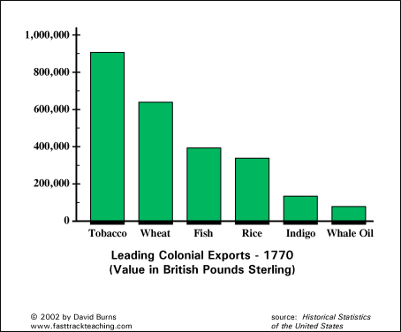

Doc. D:

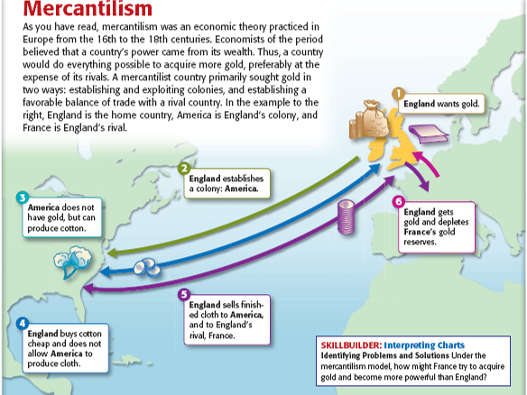

Doc. E: Plantation painting from 1716

* In which colonial region would you have found this house?
* Who might have lived in the large house on the top of the hill? Who might have lived in the smaller houses?
* What products might have traveled on the ship in the painting?



Doc. F:

* What can you assume about the importance of slave labor in the Americas over time?
* Why might slave labor have increased?

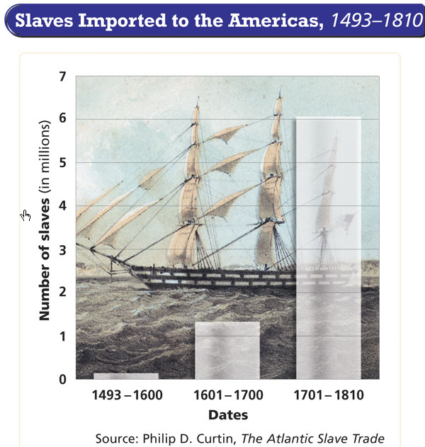

Doc. G: The Stono Rebellion

This slave **rebellion** began on September 9, 1739, in the colony of ***South Carolina***. It was the largest slave uprising in the British mainland colonies, when 150 slaves revolted. This led to 42-47 whites and 44 blacks being killed.

* What do you think southern local governments did in reaction to the Stono Rebellion?

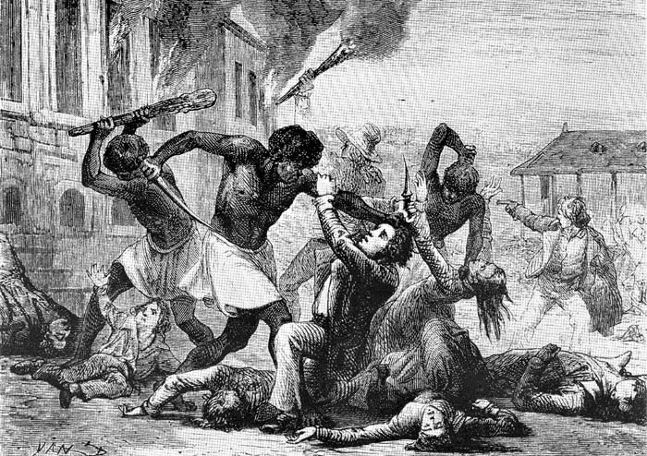

Doc. H: Populations in Colonial Cities

* Which city had the largest population in 1650?
* Which city had the largest population in 1775?
* Why do you think the populations shifted?

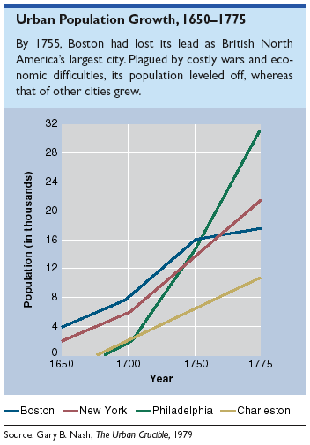

Doc. I: Map of where people were from in British Colonies

* Which region of the colonies had the most diverse population?
* Which region had the least diverse population?
* What conclusion could you draw between immigration and religions practiced in the colonial regions? 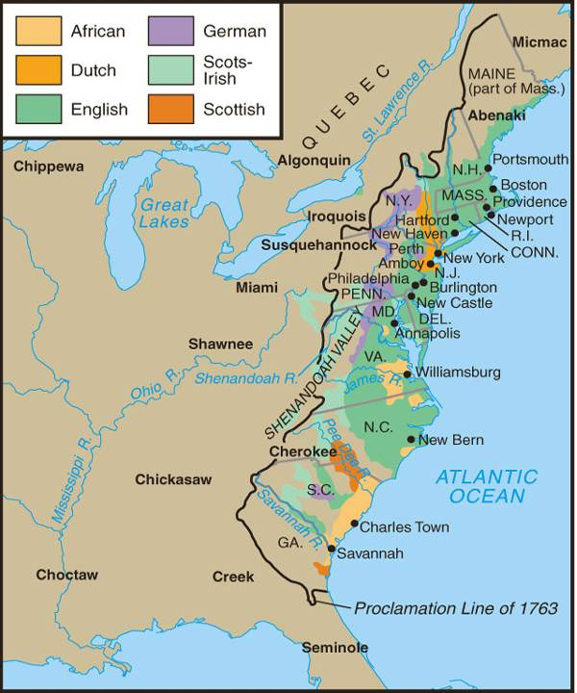

Doc. J: Practiced Religions in the British Colonies

* Which region of the colonies was most diverse religiously?
* Which region had the least diversity?
* What conclusion could you draw between immigration and religions practiced in the colonial regions?

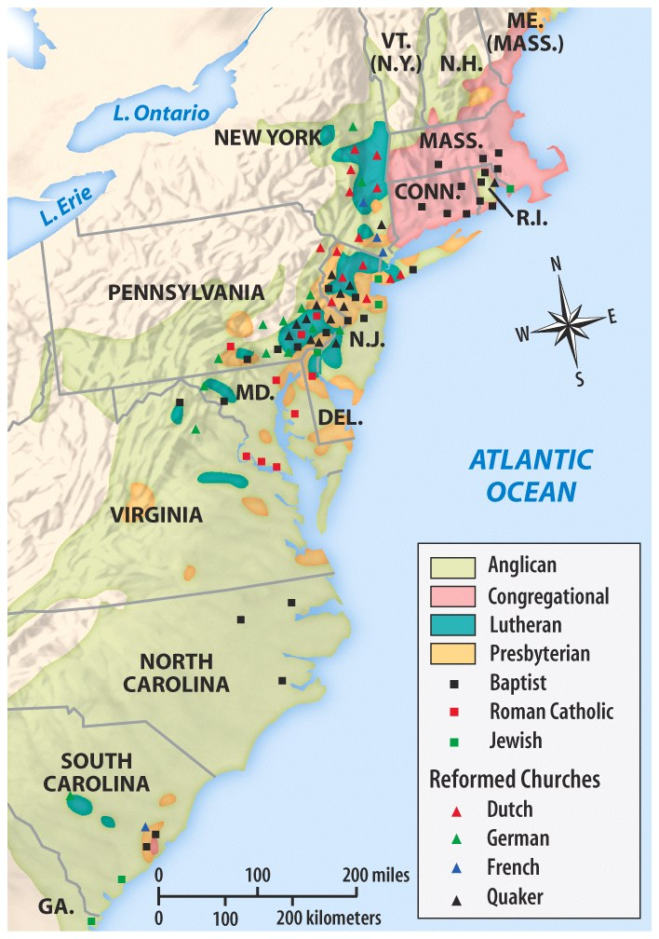

Doc. K: Education in Puritan New England  
The first colonies to be established in Colonial America were in New England and were predominantly Puritan.  The Puritans encouraged Colonial Education for religious reasons, like reading and studying the Bible. Puritan parents believed that the education of their children in religion was their primary duty. The children of Puritans were schooled in the Scriptures in daily devotions, at mealtimes and in sermons. In 1642 the Massachusetts Bay Colony established an early law that stated it was the parental duty of teaching children to “read and understand the principles of religion and the capitall lawes of this country”. It should be noted that this law was not always enforced.

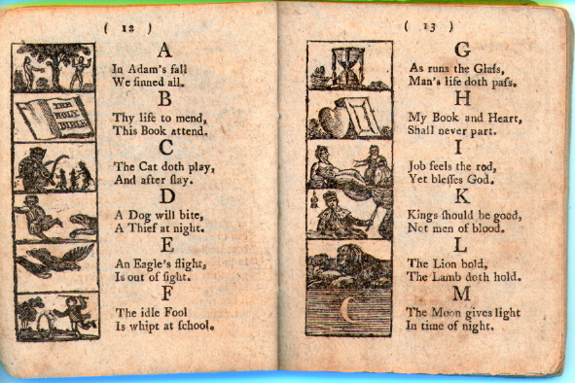

Doc. L: Colonial Education

|  |  |
| --- | --- |
| **Colonial Education of the Upper Classes** | The boys from upper class families in all colonial regions were taught with private home tutors and then sent to college or university. Many of the Upper Classes sent their boys abroad to English educational institutions in order to receive a university or college education. |
| **Colonial Education of the Middle Classes** | Boys from the middle class- the sons of merchants, ministers, doctors and lawyers- attended elementary schools and grammar schools. Only occasionally would they attend college. |
| **Colonial Education of the Lower Classes & Indentured Servants** | Limited colonial education - apprenticeships were available to some lower class boys. Apprenticeships were meant to train boys to do a job, such as cabinet making, ship building, barrel making, silver smith, and tin smith. |
| **Slaves** | Slaves had no education and in the Southern colonies slaves were forbidden by law to learn how to read and write |

Doc. M: William Penn’s meeting of Native Americans

It is uncertain whether William Penn ever signed a 'Great Treaty' in 1682 at the village of Shackamaxon. For many Americans (and non-Americans such as Voltaire) this deed proved the most inspiring 'event' of Penn's life. It is possible that Penn signed the treaty and never broke it, but that his less scrupulous successors destroyed the document, presumably so that they could renege on its provisions. Documentation proves that Penn did buy much land, so must have made at least one such agreement, instituting what was known in Indian terminology as a 'chain of friendship'. And there do exist several references to this chain being made between Penn and the Delaware Tribe.

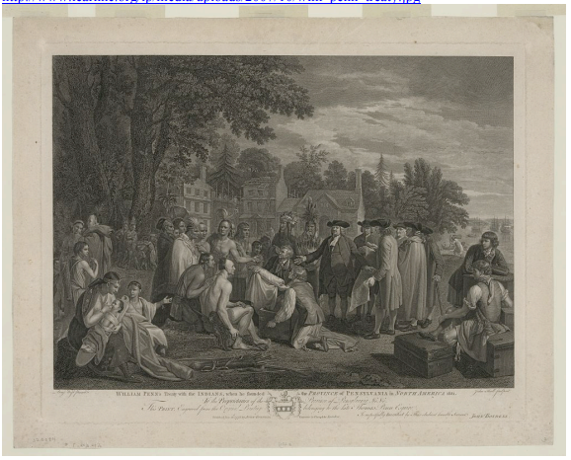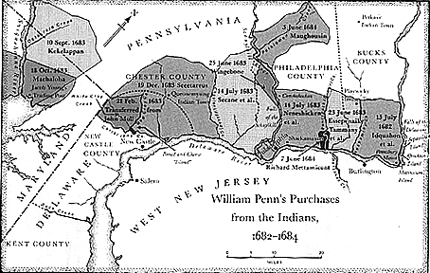Penn paid a total of 1200 pounds for the land, which though a large sum, was probably fair for both sides. Penn took the advice of Dutch and Swedish colonists who had already set some parameters for treaty agreements These earlier settlers provided invaluable assistance in delineating who to contact, and who to pay for the land. On the other side of the 'covenant chain', the Delaware Indians had many years of negotiating such treaties, and were ready to sell their land to Penn, on their terms. Disease had decimated much of their population so they needed less of the land near Philadelphia, and at the time there was plenty of un-occupied space to the North and West of the (future) city. As well, the Indian's 'ownership' of the land, was not as 'savagely simple' as had been assumed. (Jennings, 201). They worked with a complex arrangement of overlapping 'right's to use certain areas, and rights to dispose of these obligations. So Penn may have had to pay several times to the same holder in order to clear all claims. He was not 'duped' into paying several times for the same property.

Figure :The painting to the left by John Hall (1775) depicts Penn's amicable relationship with the Native Americans. The map above shows Penn’s purchases from the Indians between 1682-1684.

FIRST DOC: Colonial Regions

