Name: ________________________________ ______/20

Presidential Persona
The president plays many roles and must meet Constitutional requirements along with “unwritten” social requirements. Your task will be to create the perfect persona for one specific presidential role. Be sure you read the rubric carefully and complete all parts. Honors: You must also justify your chosen persona using a specific quote from Article II of the Constitution or data you found through research.

Step 1-Role: Choose a Role/Hat of the Presidency and write it here ____________________. This is the role you will focus on when creating the perfect presidential persona.

Step 2-Personality: Describe the personality characteristics the President would need in this role. You must list and explain/justify at least 5 needed personality characteristics for the President in your chosen role. Be sure you justify your answer. Why does the President need the Characteristics? How will it help them in this role? EXPLAIN and BE SPECIFIC!

Step 3-Clothing: Use a paper doll provided to create an outfit for the President in this role. What type of outfit would embody this role or help them do a good job in this role. Draw the outfit on the paper doll--use color! Feel free to include accessories. EXPLAIN and JUSTIFY your chosen outfit.

Step 4-Walk Out Song: Every President needs a good walkout song for each role. Choose a song that would be the perfect walk out song for the president in this role. You CANNOT use a patriotic song. Be sure to EXPLAIN and JUSTIFY the reason you chose the song you did. You may find it helpful to quote specific lyrics from the song in your explanation.

Step 5-Inner Circle: Each President chooses a group of people to advise them called the Cabinet. Choose 5 people to be in your Cabinet that would help your President in this specific role. Be sure to EXPLAIN and JUSTIFY why you chose each person.

Honors Extension (Done on Separate Sheet of Paper): Use Article II of the Constitution to justify your persona for the chosen role What does Article II say about your role? How will your persona fulfill these duties? Cite specific section number and line.

Chosen Role:

Personality Characteristics: | Explanation and Justification of Chosen Personality Characteristics:
Explanation and Justification for chosen outfit and accessories. | 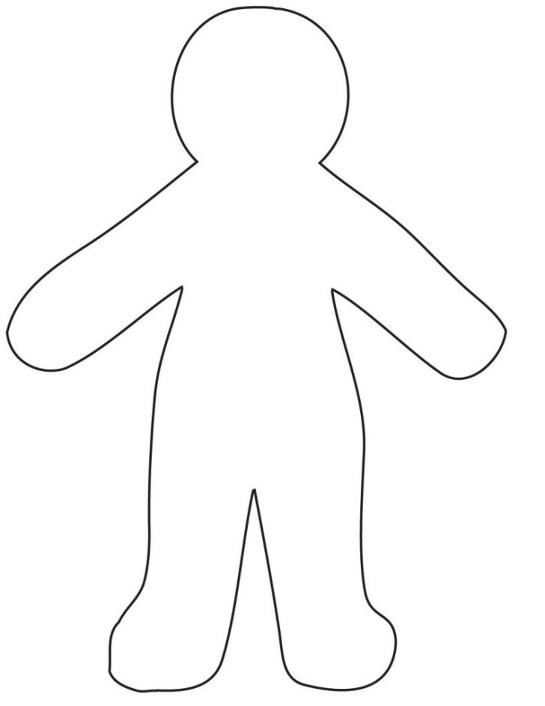
Walk Out Song  Title:  Artist: | Explanation and Justification for Walk Out Song
Inner Circle Members
Members Name | Explanation and Justification of why you chose this person.

